Lab (Optional): Undo Changes in Git
Mistakes happen—and that’s okay. Git gives you safe, simple ways to fix them.

Learning objectives
- Unstage changes: move edits from the Index (Staging Area) back to your working directory
- Reset to a commit: restore code from a previous commit using git reset (rewriting history locally)
- Revert a commit: create a new commit that undoes an earlier one using git revert (safe for shared repos)

Prerequisites
- A text editor (e.g., Vim, Visual Studio Code, or any editor you prefer)
- Git installed on your machine

Steps to follow:

- Open the visual studio code and create a new project (add a new folder, say git-workflow-undo)
- Add a file in this folder say README.md
- Update the file with the following code

# This is my first Readme file
We will commit this file to the git repository

- Save the file
- Open the VS Code terminal and navigate to the code repository
- Next, let us initialize the code repository. Execute the following command -

git init

- Next, let us verify the status of the files in the code repository.

git status

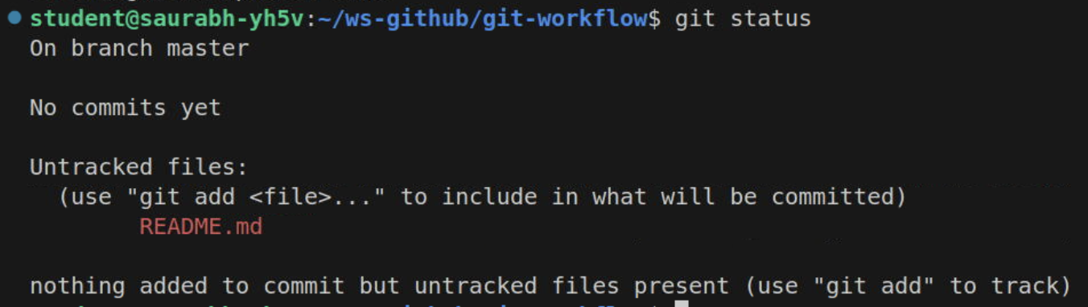

Notice - This file README.md is untracked for now.

Undo changes in the working directory

- Add the files to the Index (Staging Area)

git add README.md

- Verify the git status again.

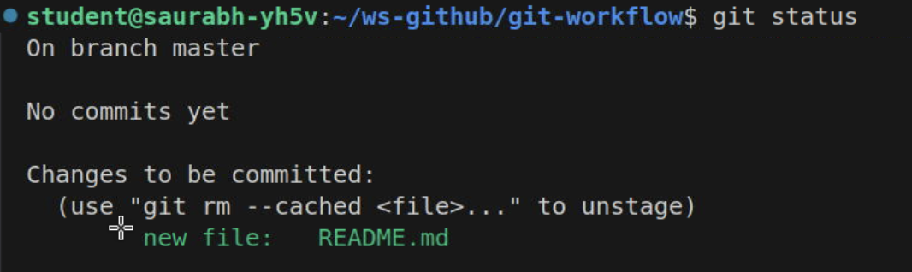

Let us now modify the README.md file in the working directory.

# This is my first Readme file
We will commit this file to the git repository
Adding more code to this file

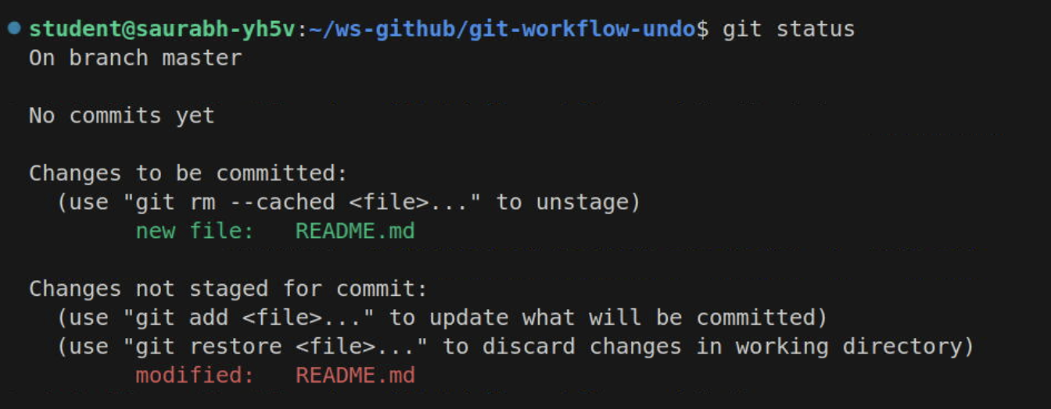

Notice, the README.md file now is modified in the working directory and is also available in the staging directory to be committed to the Object database.

Now to revert the changes in the working directory, you can run the following command.

git restore README.md

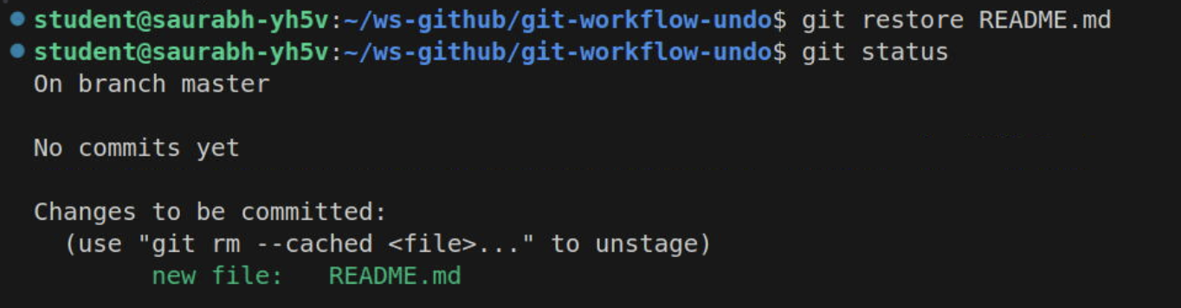

The changes from the staging area are copied to the working directory.

Undo changes to a previous commit

Let us commit the code.

git commit -m "Adding the first commit to the code repository"

Update the Working Directory and Staging area with different content in README.md file to see how various git reset options work.

# This is my first Readme file
We will commit this folder to the git repository
Update the Staging Area to show you the git reset command

git add .

Update again the README.md file with the below content.

# This is my first Readme file
We will commit this folder to the git repository
Update the Staging Area to show you the git reset command
Update the Working Directory to show you the git reset command

Check the git status

git status

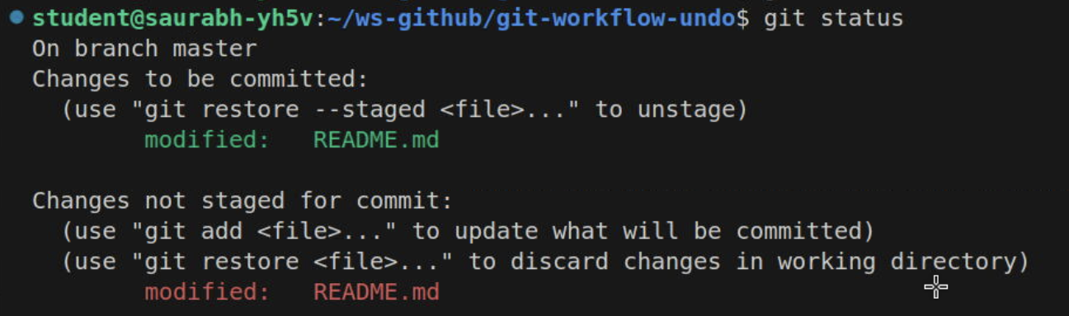

Execute the following command -

git reset HEAD --hard

This will hard reset the changes and the content from the committed code (as we are using HEAD) will be copied to the Staging Area and the working directory.

If we will use any commit Id here the code from that commit Id will be copied to the Index and the working Directory.

Amend the Commit Message

You can amend the latest commit message by executing the following command

git commit --amend -m "Updating the message to show amend command"

